Team Silver
Tyson B., Crytal L., and Rashai R.
Milestone #1
The Case study chosen was/is Outland Adventures.
Business rules, assumptions, and attributes then the tables based on them:
Each trip has a start and end date.
Each trip has a maximum group size.
A customer can book one or more trips at a time.
A trip can have many customers.
A trip occurs in a specific location (like Africa, Asia, or Europe).
A trip is organized by one guide, but a guide can manage multiple trips
Equipment can either be sold or rented to customers.
A customer can purchase or rent multiple equipment items.
Equipment has a purchase date and allows age tracking.
Each piece of equipment has a stock quantity.
The Inventory Manager is responsible for maintaining equipment records
The website will allow trip schedules and equipment listings.
Equipment older than five years may need review or replacement
- Customers need to find information on schedules with information on trek details
- Ability to purchase or rent hiking/camping equipment online or schedule it for rent/purchase at arrival
- Inventory system necessary to track and possibly automatically notify of what needs restocked
- Connections to airfare, visa regulation sites, and vaccine or consolate sites
- Something to track booking
- Each product will need its own id for the program
- Employees can only manage order entry but not suppliers or inventory updates
- Order details will be tracked separately in a join kind of table maybe
- Even if product item count is 0 it still stays on the table (maybe once it hits 0 a message would display time to reorder)
- Only the existing suppliers will be assigned to new product
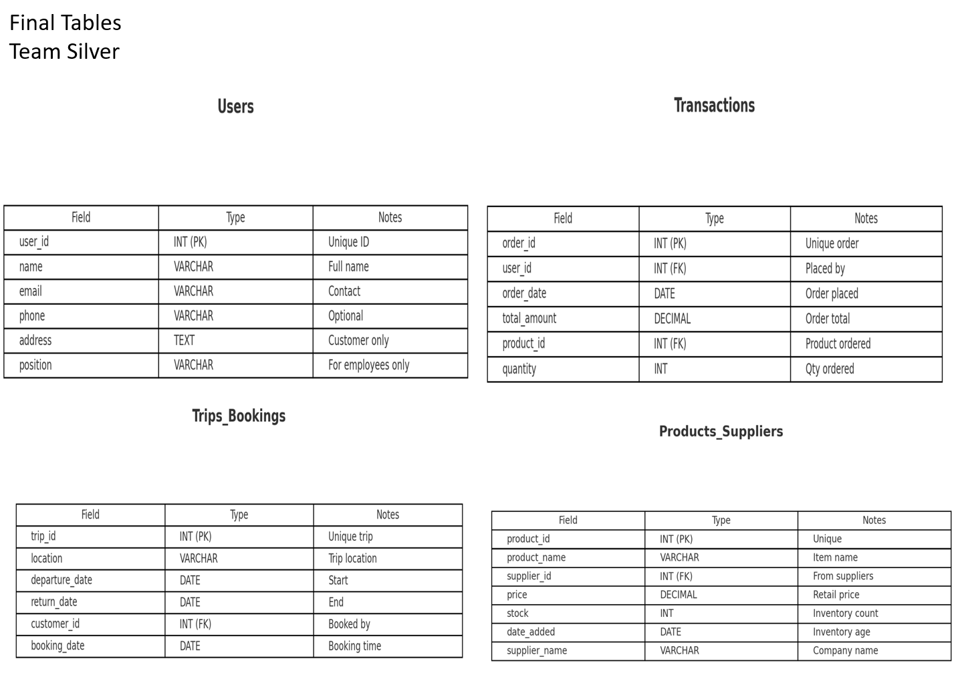
Initial ERD
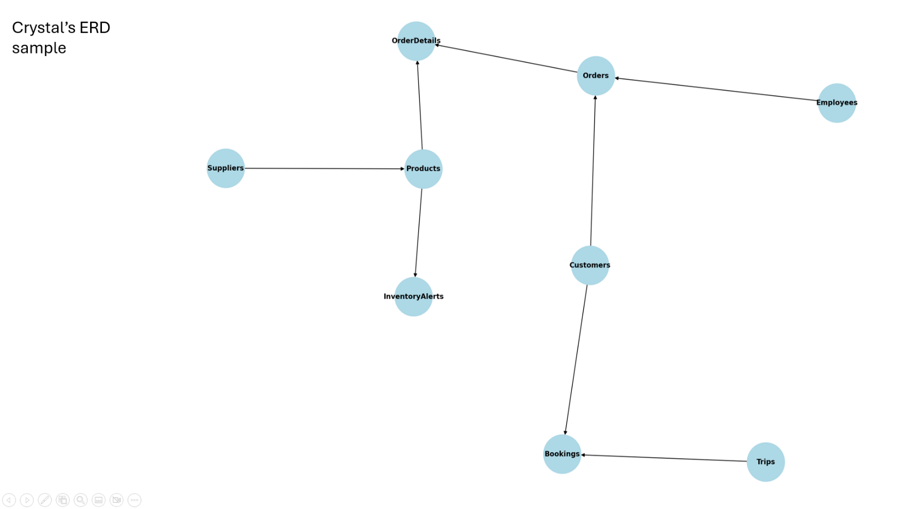
2nd ERD below.
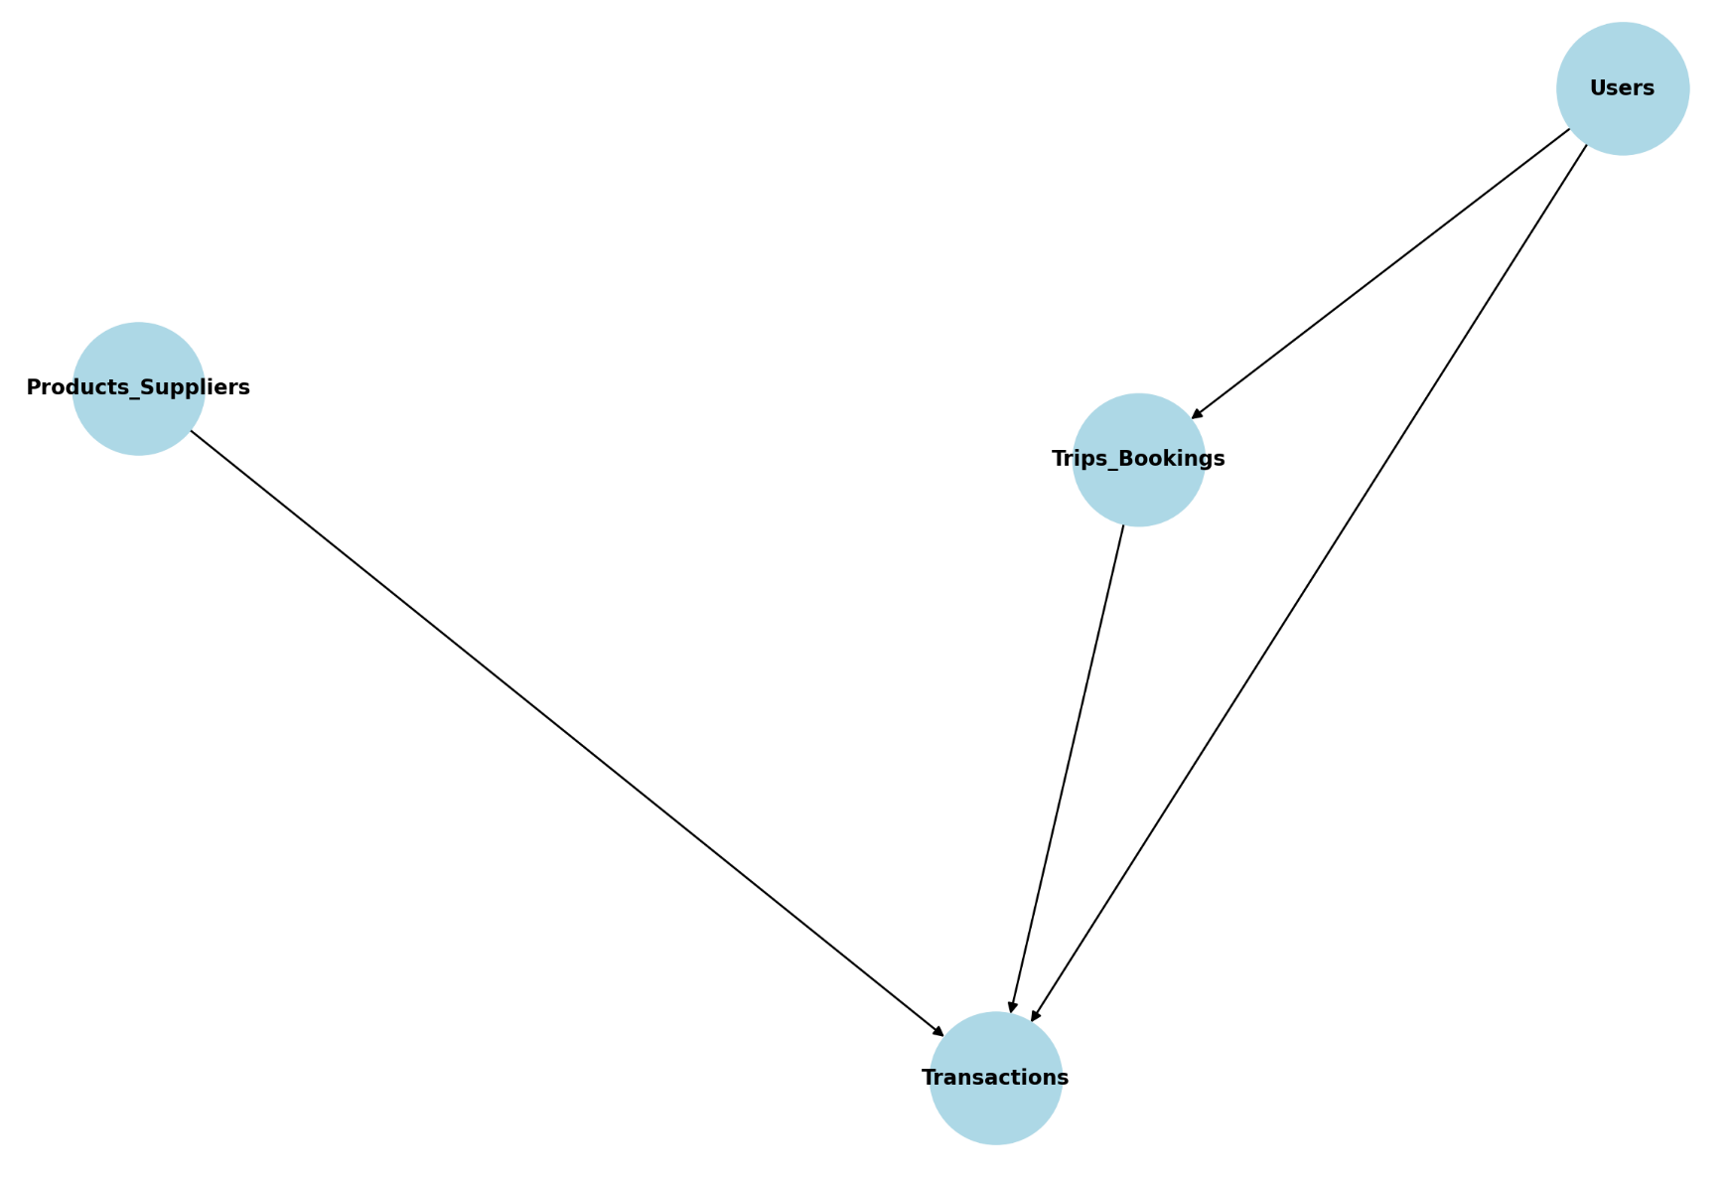
Final ERD
